**Experiment No:** 01

**Experiment name:**  Install Linux Mint in the PC.

### Advantages: ****i)Reliability**** includes stability of the code, not needing frequent updates, protection from viruses and of course not crashing.

### ****ii)Easy Setup**** means it does not require installing extra tools to operate and can achieve a state of maximum usability with only a few minor adjustments.

### ****iii)File Organized**** means the file structure can be quickly configured in an open and simple tree structure of folders and files so that all files and all tools can be quickly and reliably accessed.

### ****iv)Easy Use**** means that there are no hidden files or tools. All files, tools and menus are clearly labeled to assist the novice in learning how to use the operating system

### ****v)Versatile**** means that it is compatible with other programs.

### 

### How To Create A UEFI Bootable Linux Mint USB Drive:

### The tools required to create a UEFI bootable Linux Mint USB drive are as follows:

* Linux Mint ISO
* Universal USB Installer
* Win32 Disk Imager
* A blank USB drive
* A laptop with Windows 8.1 pre-installed
* There are 4 versions of Linux Mint available:
* Cinnamon
* MATE
* XFCE
* KDE

The Cinnamon desktop is the main version and provides a great user experience with a modern looking environment. To find out whether my computer is 64-bit press the start button and search for system information.

**The Disk Management Tool:**

Once i have tried using [Linux as a live USB](https://www.lifewire.com/create-uefi-bootable-ubuntu-usb-drive-2202085) and I am beyond [using it within a virtual machine](https://www.lifewire.com/run-ubuntu-within-windows-virtualbox-2202098) i might decide to install Linux to my hard drive. This guide helps i prepare my disk for dual booting Linux and Windows 8. The process is quite straight forward but it needs to be done prior to installing Linux.The tool that i will use for this task is called the "[Disk Management Tool](https://www.lifewire.com/disk-management-2625863)". I can start the disk management tool by switching to the desktop and right clicking on the start button.

.A menu will appear and half way up the menu is an option for "Disk Management Tool".

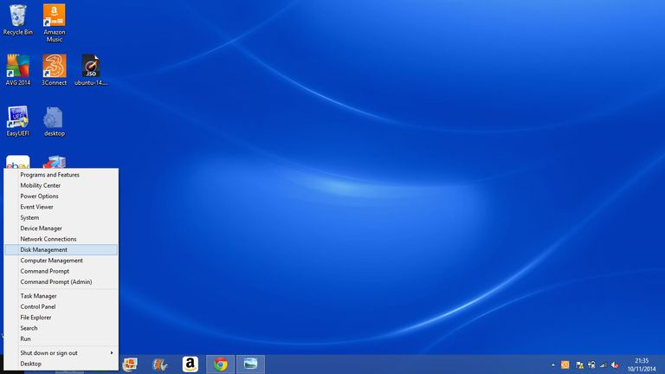

**Choose the partition to shrink:**

Look for the partition that runs my OS. If you are lucky it will be called OS or Windows. It is likely to be the largest partition on my drive.When i have found it right click on the OS partition and choose "Shrink Volume".

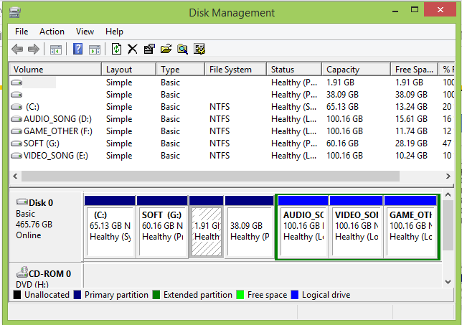

**Shrink The Volume:**

The "Shrink Volume" dialogue displays the total disk space available in the partition and the amount that i can afford to reduce it by without damaging Windows.Before accepting the default option consider how much space i will need for Windows in the future and also how much space i wish to give over to Linux. In the next article in this series I will show how to actually install Linux alongside Windows 8.1.

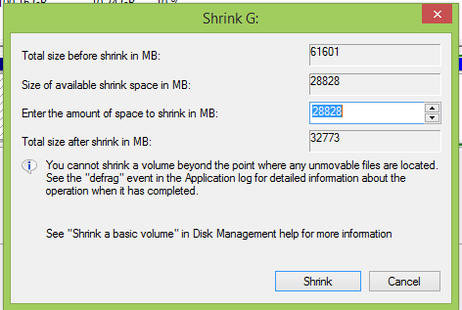

# Universal USB Installer:

 The Universal USB Installer is easy to use. Simply choose a Live Linux Distribution, the ISO file, my Flash Drive and, Click Install. Upon completion, i should have a ready to run bootable USB Flash Drive with my select operating system installed. Other features include; [Persistence](https://www.pendrivelinux.com/what-is-persistent-linux/) (if available) – Ubuntu, Xubuntu, and Lubuntu Casper Persistence feature works with FAT32 or NTFS formatted drives. Larger than 4GB casper-rw is possible only when the USB drive is formatted with the NTFS filesystem.

### F:\3rd Year 1st Semester Books\Operating system\Linux Setup Photos\Capture4.PNG

### F:\3rd Year 1st Semester Books\Operating system\Linux Setup Photos\Capture5.PNG

### F:\3rd Year 1st Semester Books\Operating system\Linux Setup Photos\Universal-USB-Installer2.png

### Turn Off Fast Boot To Make It Possible To Boot From USB:

In order to boot a UEFI bootable Ubuntu USB drive, i need to turn off a fast start up .Move the mouse to the bottom left corner and right click so that the menu appears again .Choose "power options".When the [power options](https://www.lifewire.com/how-to-access-advanced-startup-options-in-windows-10-or-8-2626229) screen appears to click the second menu item on the left-hand side called "Choose what the power button does".At the bottom of the window is "Shutdown Settings". Make sure the "Turn on fast startup" checkbox is unchecked and click "Save Changes".Here is the list of function keys used by a manufacturer:HP - Escape, F1 or F10

### F:\3rd Year 1st Semester Books\Operating system\Linux Setup Photos\Capture6.PNG

### Dual Boot Windows 8.1 And Linux Mint:

### Windows 8.1 take up a large amount of space on my hard drive although most of it will be unused.I can use some of the unused space to install Linux Mint but to do so i have to shrink my Windows partition.To start the installer click the "Install" icon from the live Linux Mint desktop. The first real step is to choose my language. Unless i feel like a challenge choose my native language and click "continue".However in order to reduce the number of ISOs produced this is now an installation option.I recommend checking the box.

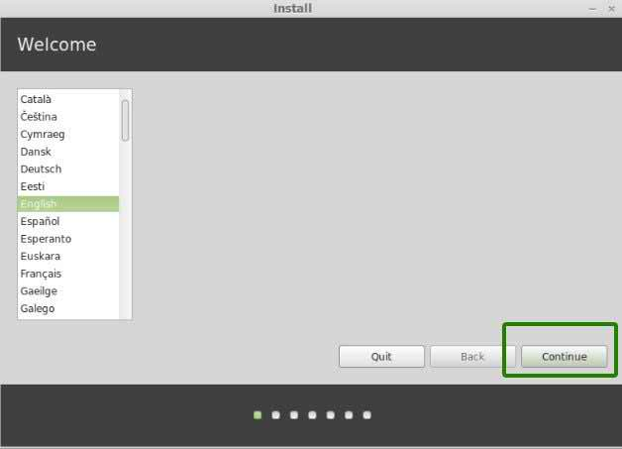

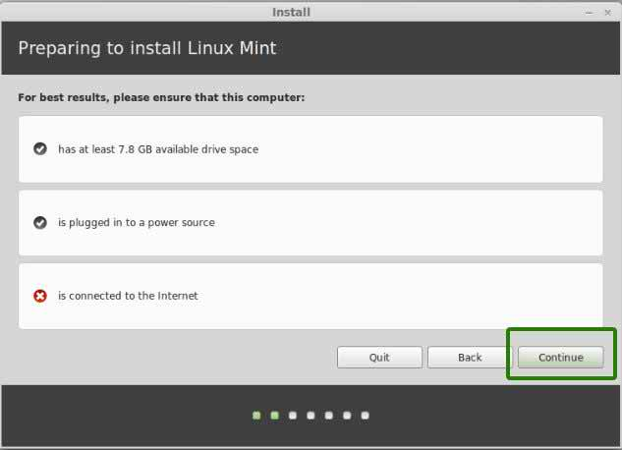

### How To Create The Linux Mint Partitions:

### The next step is the most important part. I will see a screen with the following options:

1. Install Linux Mint alongside Windows Boot Manager
2. Erase disk and install Linux Mint
3. Something else

Choose the first option to install Linux Mint 18 alongside my version of Windows .If i want to make Linux Mint the only operating system choose the 2nd option. This will wipe my entire hard drive.If i had to choose the something else option then i will need to create the Linux Mint partitions manually .A list of partitions will appear. Click on the words "Free Space" and click the plus icon to create a partition .I need to create two partitions:

1. Root
2. Swap

When the "Create Partition" window opens enter a number which is 8000 megabytes less than the total free space available in the "size" box. Select "primary" as the "partition type" and set "use as" to "EXT4" and "/" as the "mount point". Click "OK". This will create the root partition.Finally, click on the "Free Space" and the plus icon again to open the "Create Partition" window. Leave the value specified as it is (it should be around the 8000 mark)  as the disk space, select "primary" as the "partition type" and set "use as" to "swap". Click "OK". This will create [the swap partition](https://www.lifewire.com/do-you-need-swap-partition-2202049).

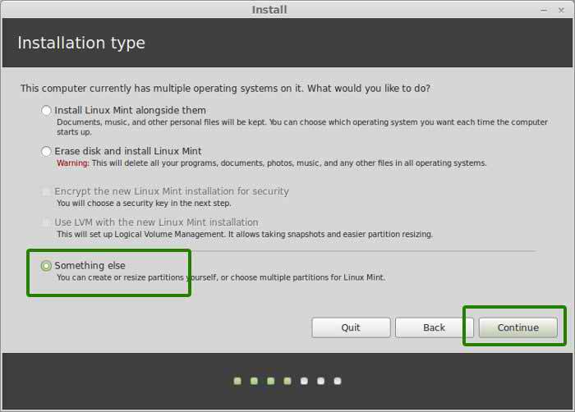

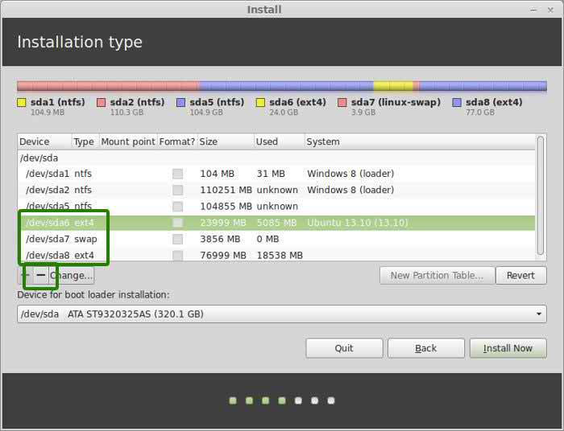

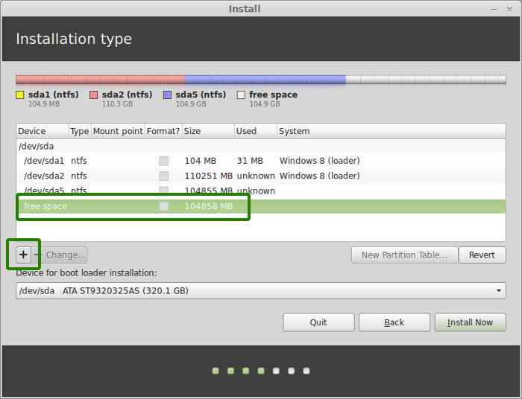

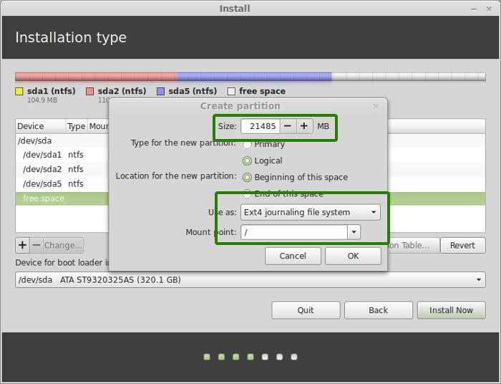

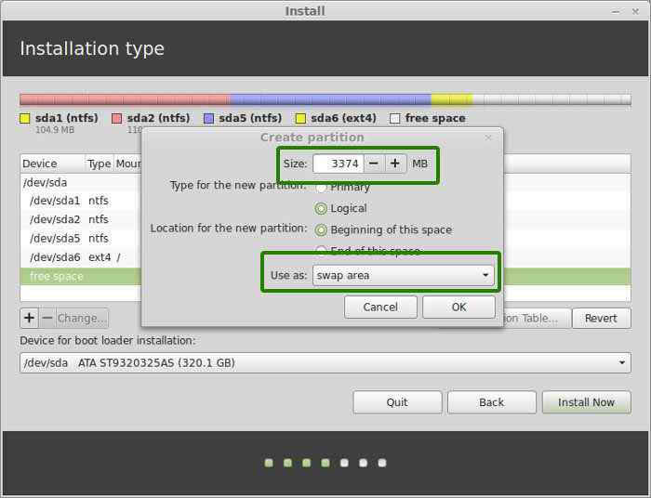

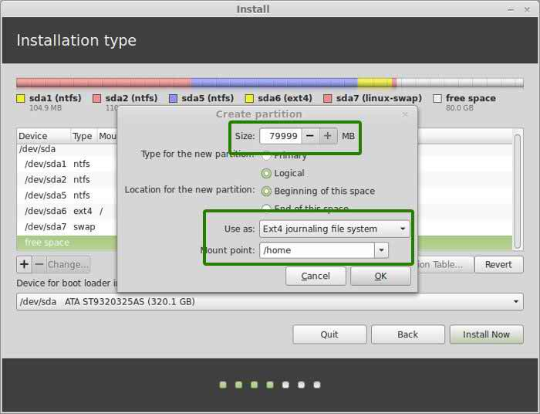

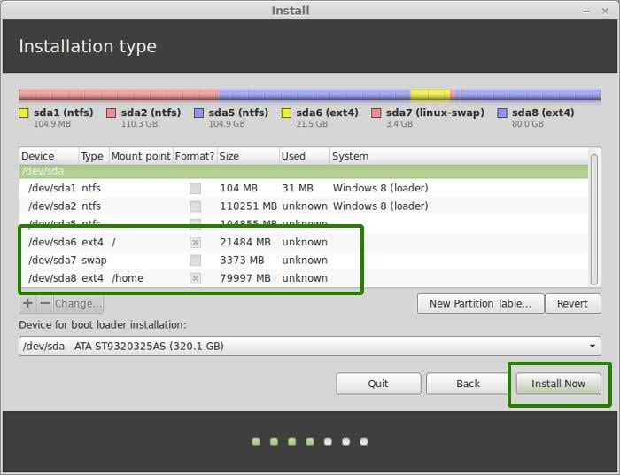

### Choose Your Location And Keyboard Layout:

### Whilst the files are copied across to my system i have to complete a few more steps in order to setup Linux Mint .The first of these is to choose my time zone . Simply click my location on the map and then click "Continue".The penultimate step is to choose my keyboard layout .This step is important because if i don't get this right, symbols on the screen will appear to be different to the ones printed on my keyboard keys.Choose my keyboard's language in the left pane and then choose the correct layout in the right pane.Click "Continue".To be able to login to Linux Mint the first time i will need to create a default user .Enter my name into the box provided and then give my computer a name that you will recognize. (This is useful if i try to connect to shared folders from another computer and to identify it on a network).Pick a username and enter a password to be associated with the user. (i will need to confirm the password).If I am the only user of the computer then i might want the computer to login automatically without having to enter the password otherwise click the option to require to log in. I advise leaving this as the default option.I can choose to encrypt my home folder if i so wish.Click "Continue".

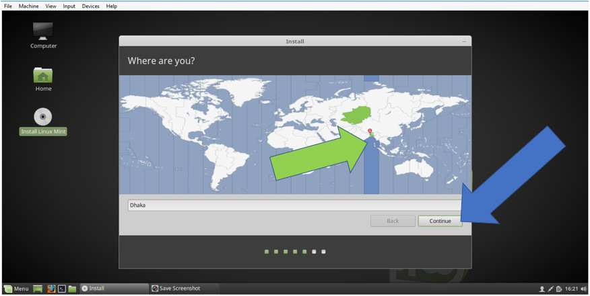

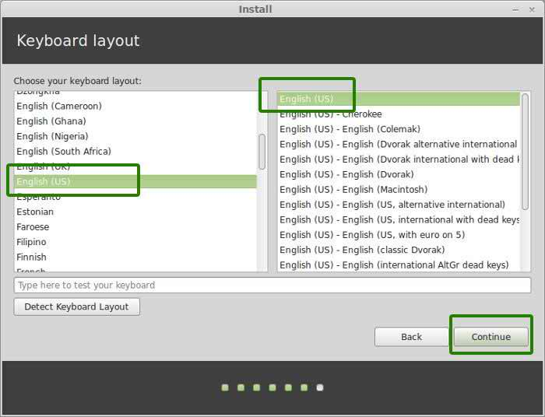

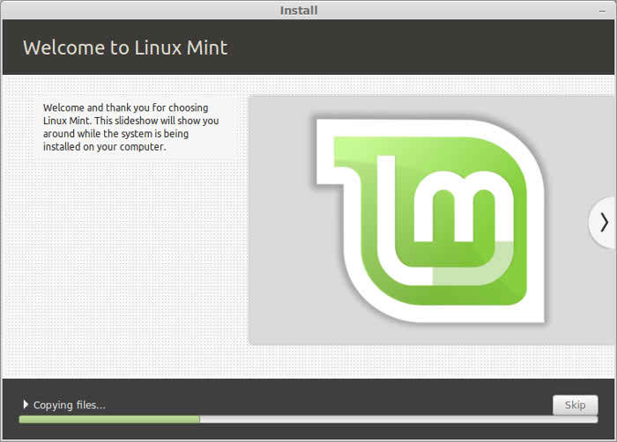

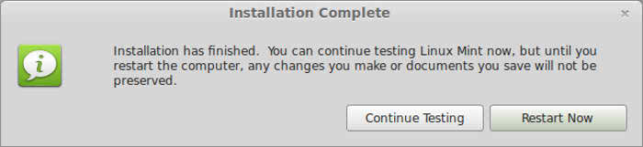

### Conclusions:

Linux Mint 17 is a very solid release that further improves on Linux Mint's own look and feel, especially in its Cinnamon version.Linux Mint seems ready to step into the breach and present a version of Ubuntu targeted with its full might at the desktop.It is highly secured system & does not affected any virus.